PRACTICAL NO. 11
AIM: Creating Forensic Image using FTK Imager/Encase Imager:
- Creating Forensic Image
- Check Integrity of Data
- Analyze Forensics Image

STEPS FOR INSTALLATION:
- Install latest version of AccessData FTK Imager.
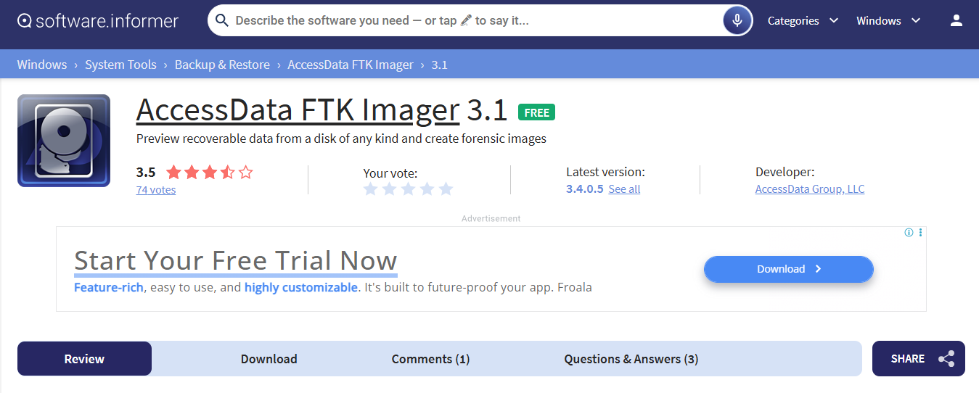
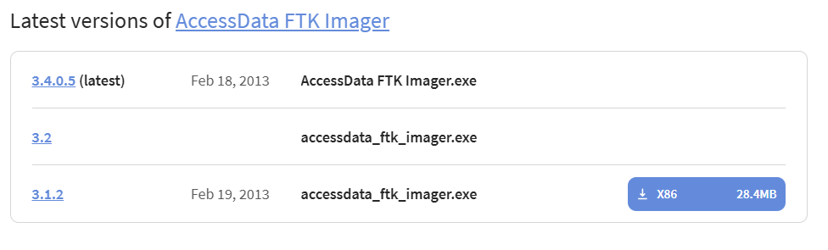
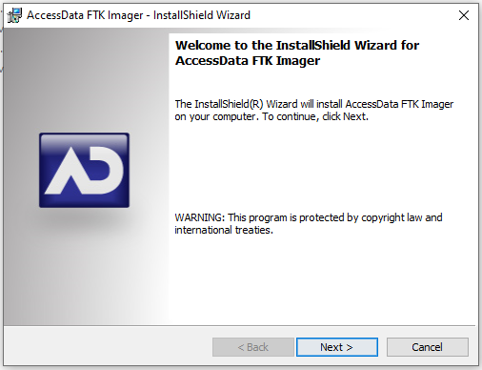

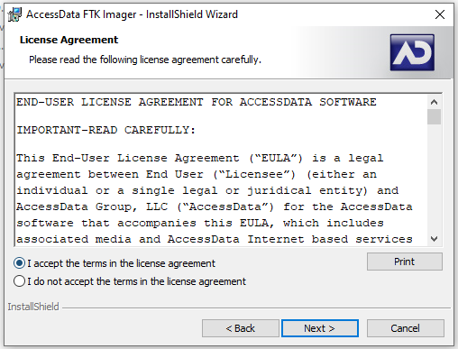
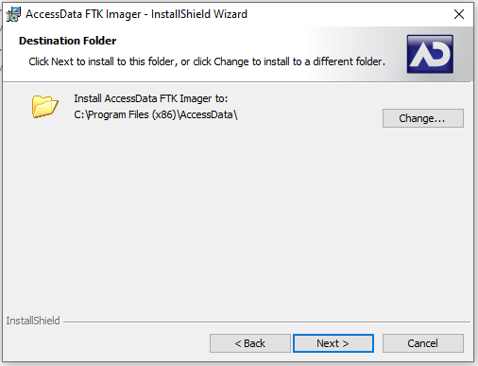

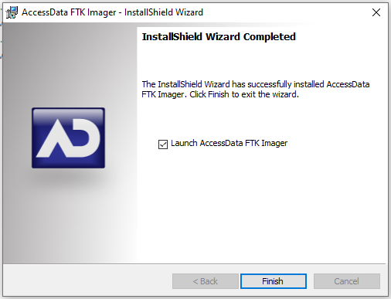

STEPS FOR CREATING FORENSIC IMAGE:
- Click File, and then click on Create Disk Imager.
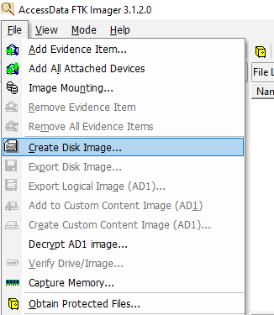

- Select the Source Evidence Type you want to make an imager of and click Next.
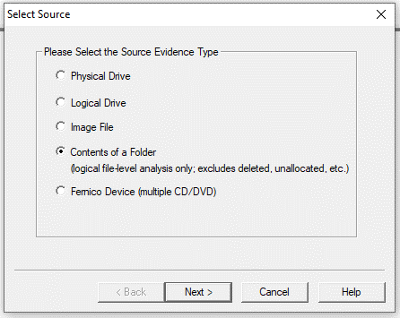

- Click Yes.
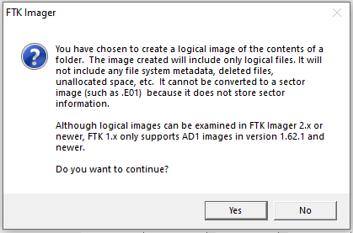

- Select the source evidence file with path.
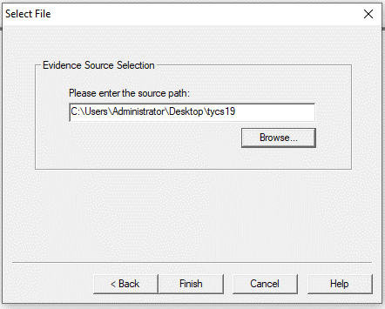

- Click on “Add” to add image destination.
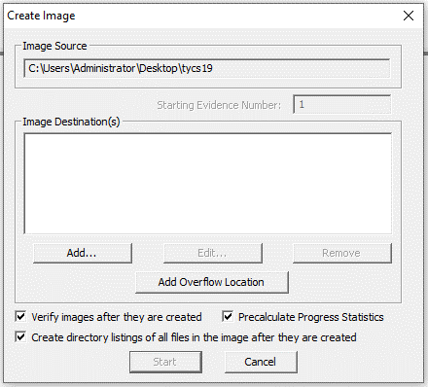

- Fill the details and click Next.
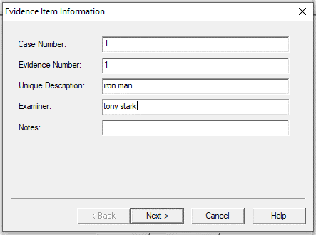

- In the Image Destination Folder field, type the location path where you want to save the image file, or click Browse to find to the desired location.

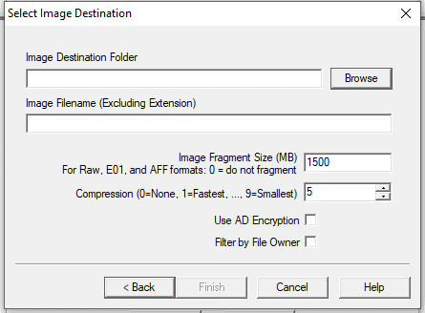
Note: If the destination folder you select is on a drive that does not have sufficient free space to store the entire image file, FTK Imager prompts for a new destination folder when all available space has been used in the first location. In the Image Filename field, specify a name for the image file but do not specify a file extension.
- After adding the image destination path and image name click on Finish.
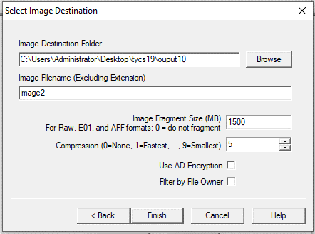

- Tick on all the boxes and start the image processing.
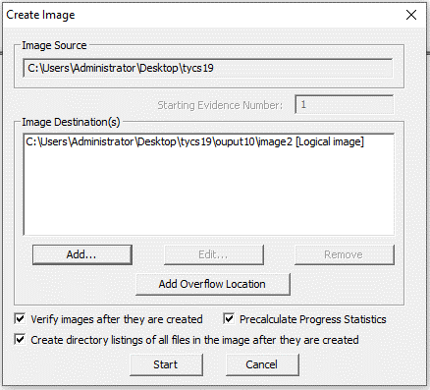

- After the images are successfully created, Image Summary views the detailed file information, including MD5 and SHA1 checksums.
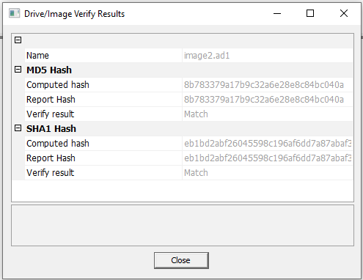

STEPS FOR ANALYZE FORENSIC IMAGE:
- Click on Add Evidence Item to add evidence from disk, image file or folder.
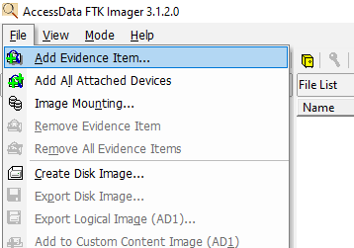

- Now Select the Source Evidence Type as Image File.
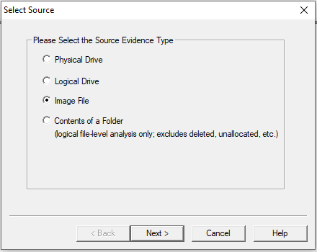

- Open the created evidence file image.
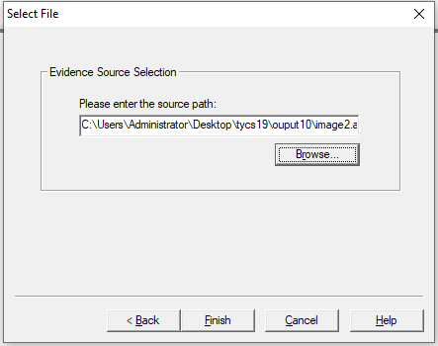

- Now select Evidence Tree and Analyze the image file.
